DETAILED INVESTIGATION REPORT

Proposal No. | 9103112313
Life Assured Name | Mr. Raveekant
Allocation date | 20-08-2026
Verification Type | Direct Visit
Address (Complete address) | S/O: Mahesh,219, Nagla Sanja, Akosh, Chhata, Mathura Pin Code 281301 State Uttar Pradesh
Mobile No. | 6395141514
Mention alternate number/email-ID if given | N/A
Verification date | 22-08-2026
OBSERVATIONS OF THE INVESTIGATORS

Report Overall Status | Positive
Verifier Name | Navratan
ID Card Seen – Yes (Name of ID proof along with complete number) | Aadhar card (XXXX XXXX 4316)
Address Proof Seen – Yes (Name of ID proof along with complete number) | Pan card (DAYPR6435R)
Name Of Person Met (Name & Mobile No.) | Mr. Raveekant
Met Person Relation With LA | LA (Self)
LA Date of Birth | 01-01-1976
LA Health Condition and lifestyle (any adversity – history of Tobacco/ Alcohol or Smoking / swimming / diving etc.) | Looking wise LA is fit and healthy and he is not having any health issues.
In case LA not healthy –Name of disease/ duration/Place of treatment (hospital and Doctor name) | N/A
Any history of medical investigation, surgery or treatment in past or planned in near future (even if it was a minor or major) | N/A
Family Medical History | N/A
Treatment papers/Audio/Video captured –In case of any adverse finding | N/A
Policy Details Other Than Canara HSBC and total life coverage | N/A
Residence Locality and type | Urban
Residence Ownership | Owned house
No of Year at Current Residence | By birth
Financial Status of Life Assured (Please mention your observation basis life style etc.) | Middle Class
No. Of Family Members and their details | Total- 05 (LA, LA’s wife and his 3 sons)  Earning member-01 (LA)  Dependent- 04 (LA’s wife and 3 daughters)
LA’s Education Qualification | 10th passed
Employment Category (Salaried /Self-employed etc.) | Self-employed
Organization Name (Employer Name) and nature of work (In case Salaried) | N/A
Self Employed (Firm Name, Business type and address) | Jewellery shop
Annual income | Approx. 5 lac per annum
Nominee Name and relationship with LA | Mrs. Harshit Verma (son)
Vicinity Check Details – met person Name / Mobile number and details confirmed | - Vinod Mo Number. Not shared  - Krishna Mo Number. Not shared
Discreet Check:- As per the discreet check, nearby people know LA and confirmed that he resides at the mentioned address with his family. They stated that he is married and there are five members in his family. They also informed that he is engaged in farming and also owns a Jewellery shop. Regarding his health, nearby people confirmed that he is fit and healthy. Overall, they shared positive feedback about the LA.
Residence Visit: - When the IO visited the mentioned address, he met with LA. LA shared that the mentioned address is his owned house and he has been living there earlier.

Health and Habits:- As per the LA, he is fit and healthy and he is not having any health issues.

Family Details:- Total- 05 (LA, LA’s wife and his 3 sons), Earning member-01 (LA), Dependent- 04 (LA’s wife and 3 daughters)

Investigation Findings:-
When the IO visited the mentioned address, he met the LA. IO introduced himself as a representative of HSBC Canara Life Insurance and, after showing his authority letter, collected the required information.
The LA informed that the mentioned address is his own house and that he has been residing there since birth. He is married, and there are five members in his family. LA is 10th passed and owns a jewellery shop. He also owns 1 bigha of agricultural land. His annual income from the business and agriculture is approximately Rs. 5 lac. LA stated that he is fit and healthy and has no health-related issues.
Regarding the policy, the LA informed that his son, Mr. Harshit Verma, is the nominee. He stated that he pays an annual premium of approximately Rs. 1,50,000 for the next 7 years. LA also provided his Aadhaar Card and PAN Card as KYC proof, which are attached to the report.

Note:- As per the IO’s findings and based on the overall findings, this case is positively closed.

- Photo of LA house with Geo tagging

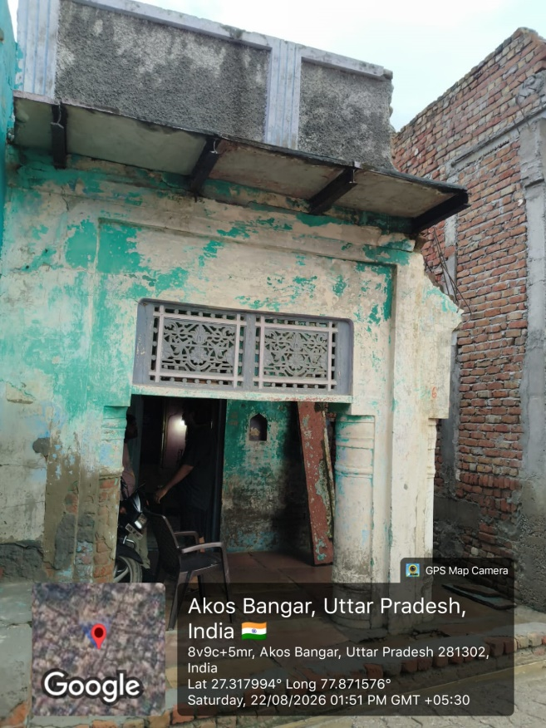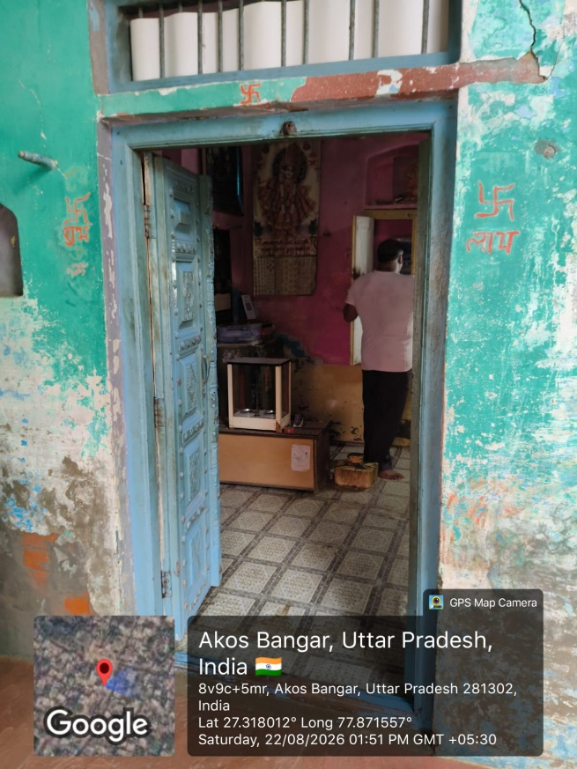

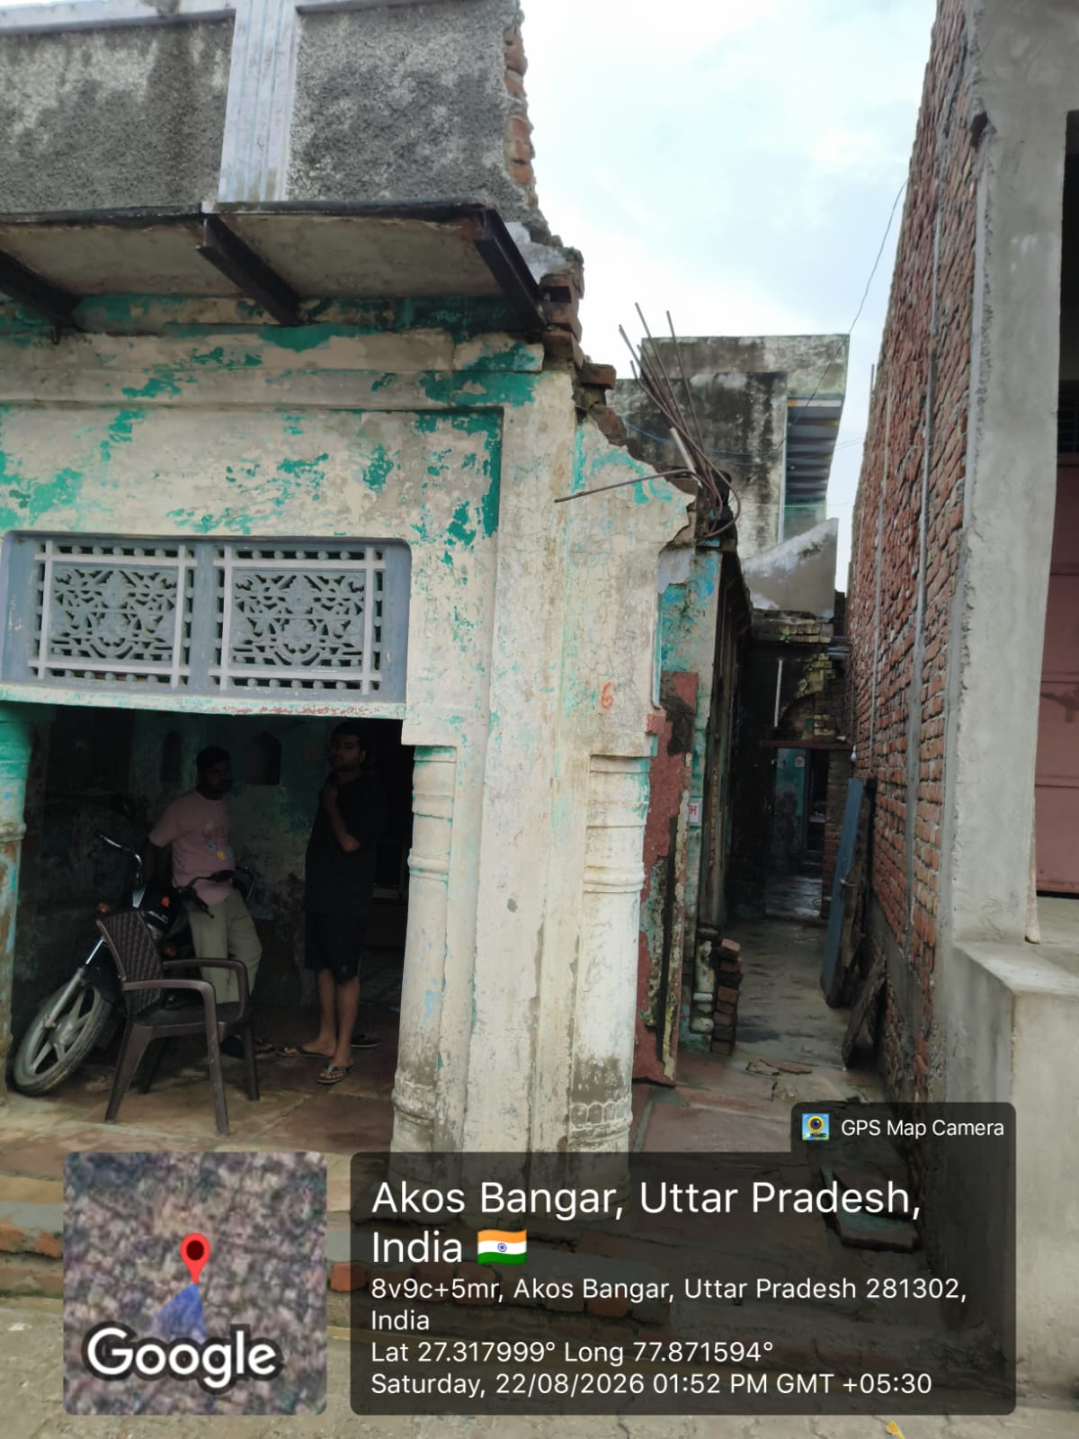
- Photo of LA or met person with Geo tagging

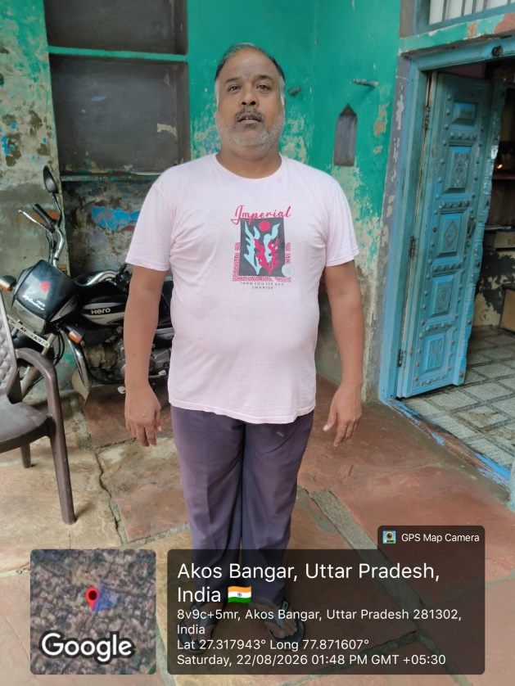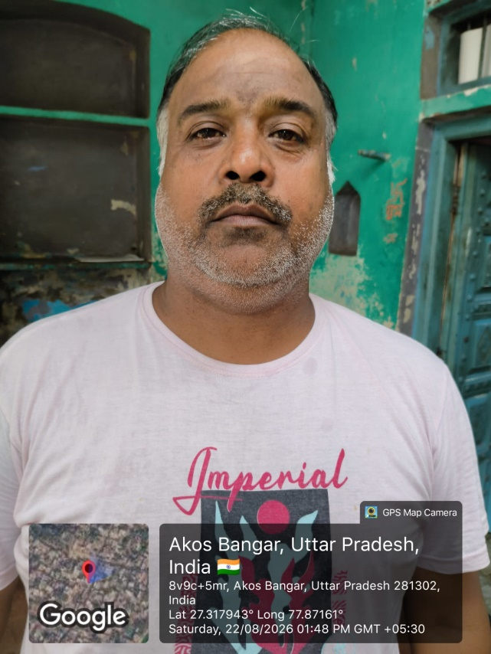

- Photo of LA’s KYC with Geo tagging

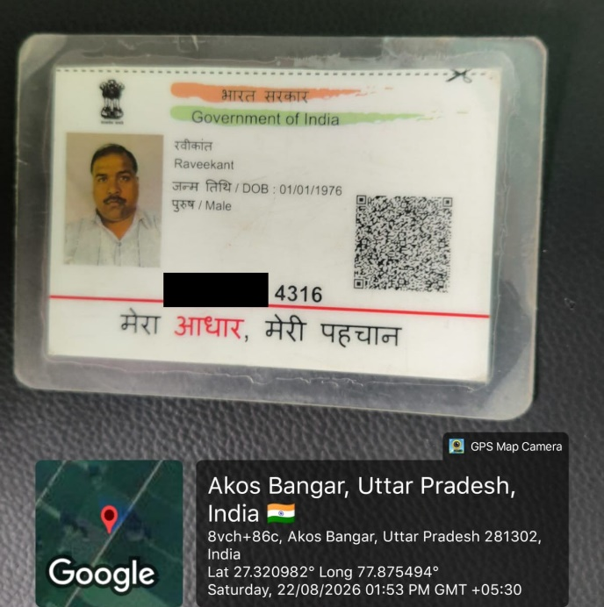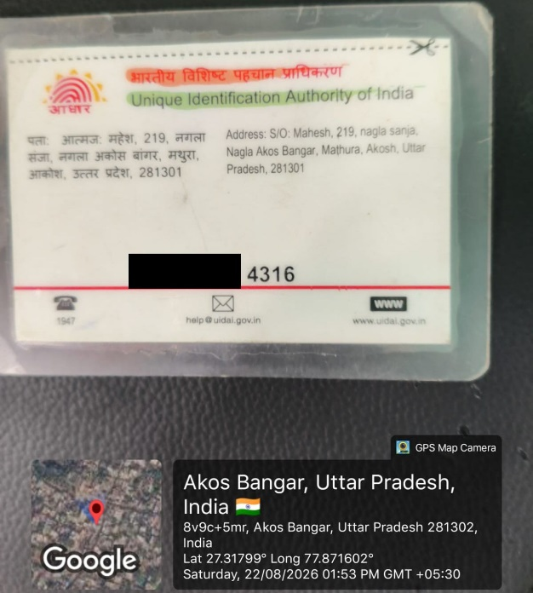

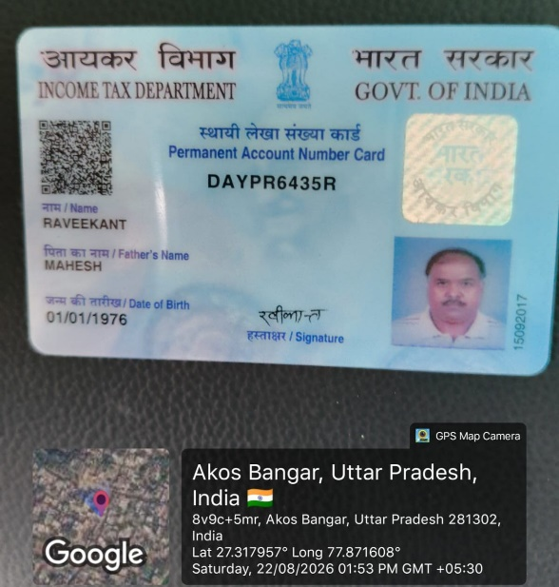

- Field Executive selfie with Geo tagging

